**CP2013** ASSESSMENT TASK 3: **Project part-2 (Audit)**

This assessment task has been prepared by Dr. Dmitry Konovalov for James Cook University. Updated 4 January 2016.

**© Copyright 2015**

This publication is copyright. Apart from any fair dealing for the purpose of private study, research, criticism, or review as permitted under the Copyright Act, no part may be reproduced by any process or placed in computer memory without written permission.

## ASSESSMENT TASK DESCRIPTION

This task is the Audit of: (i) your group ICT solution delivered to the client, and (ii) ***individual contributions*** to the overall team effort and results. In terms of the Agile Software development, this is the ***iteration-2***. It delivers the ***alpha release*** to the client.

## [Total awarded _____ out of 100 marks] ASSESSMENT TASK CRITERIA SHEET

***NOTE! Students from the same team may be awarded different marks for this assessment item. To arrive at the individual student marks, your lecturer may consider all or some of the following contributing factors: your team overall marks; team feedback forms; personal observations of the student project contribution; student workshop attendance and subject participation; student competency during workshops, this audit and the project presentation.***

The following is the list of items which are required to be completed in this assignment. Maximum possible marks are given in brackets at the beginning of each item. Where relevant, the SLOs and BLO are specified.

**[_____/Prerequisite for marking]** Assignment is completed using electronic copy of ***this*** document and submitted to LearnJCU electronically.One submission per team.

**[_____/20 marks, SLO-3, BLO-S3, BLO-S5] *Individual* Team Feedback form is submitted to LearnJCU electronically.** One submission per student. Assignment is done in a group with 2-4 students.

Write group members here:

Bui Vu Nam, Java Coder, 13196026; specific ***individual*** contributions to this assessment item.

Minh Huynh, Java Coder and MySQL (back-end) in charge, 13189895; specific ***individual*** contributions to this assessment item.

Riya Sen, Project Manager, Java Coder and Presentation in charge, 13106631; specific ***individual*** contributions to this assessment item.

**[_____/40 marks, SLO-1, SLO-2, SLO-3, SLO-4, BLO-S3, BLO-A1] Report and demonstrate the *ACTUALLY* delivered alpha-release (see your user stories in iteration-1).** Any deviations from the alpha-release-iteration-1 must be documented and briefly explained. Screen-shots (or illustrations) of running alpha-release with comments or explanations.Write here: Minimum **TWO** pages, maximum **TEN** pages.

|  |  |  |
| --- | --- | --- |
| User Story Title | Description and Assessment  (Priority: 10- High; Risk: 0- No Risk) | Effort put each day (5hours/day) |
| Milestone 1 | Week 5  (07/12/2015-12/12/2015) |  |
| 1. Add Employee | Description: The admin of the IT staff logs in into the SQL server of the system. Then the HR can add a new employee, and the information gets saved into the database.  Assessment: Priority: 10; Risk: 1 | 3 |
| 2. Edit Employee | Description: HR can edit the existing employee data saved already in the database, the unique EmpID cannot be edited. Also, HR can update the following details such as: Employee type, Hourly or Daily rate, Fixed amount, Bank Account name and Bank Account Number.  Assessment: Priority:10; Risk: 1 | 4 |
| TOTAL HOURS SPENT |  | 7 |
| Milestone 2 | Week 6  (14/12/2015-19/12/2015) |  |
| 3.Delete Employee | Description: HR will be able to perform this function  Assessment: Priority: 10; Risk: 1 | 3 |
| 4. Enter Time Card | Description: The HR updates everyday task of every Employee by his/her EmpID. HR is able to record the Start Time (ST), End Time (ET). Accordingly, the salary would be calculated later.  Assessment: Priority: 10; Risk: 1 | 4 |
| TOTAL HOURS SPENT |  | 7 |
| Milestone 3 | Week 7  (21/12/2015-26/12/2015) |  |
| 5.Calculate Salary | Description: The HR calculates each employee’s salary based on their EmpID, number of hours they work based on the pay rate fixed for him/her by the employer, all information in the database. The end result is calculated automatically by the Database and stored by it. The payment records are updated after every salary calculation of every employee.  Assessment: Priority:10; Risk: 2 | 6 |
| 6.Make Payment | Description: This function has been collaborated with the above User-Story, as both of the functions are very much similar.  Assessment: Priority:10; Risk: 1 | 0 |
| TOTAL HOURS SPENT |  | 6 |
| Milestone 4 | Week 8  (28/12/2015-01/01/2016) |  |
| 7.Salary Calculation Report | Description: The HR gets to create a report which provides all the salary calculation transactions for each employee up to current date.  Assessment: 10; Risk: 1 | 5 |
| TOTAL HOURS SPENT |  | 5 |
| ROUND TOTAL |  | 25 |

**Therefore, 25 hours was the total time required to finish the entire project.**

**[_____/20 marks, SLO-2, BLO-K1, BLO-K3, BLO-S5] Client signed acceptance of the alpha-release**. Any changes from iteration-1 are approved by the client. Write here: Minimum **TWO** pages, maximum **TEN** pages.

[____/10 marks] Describe and demonstrate how you applied the software verification, testing, and validation for quality assurance of your IT project.

Below is the attached mail sent by the client after reviewing the alpha-released system:

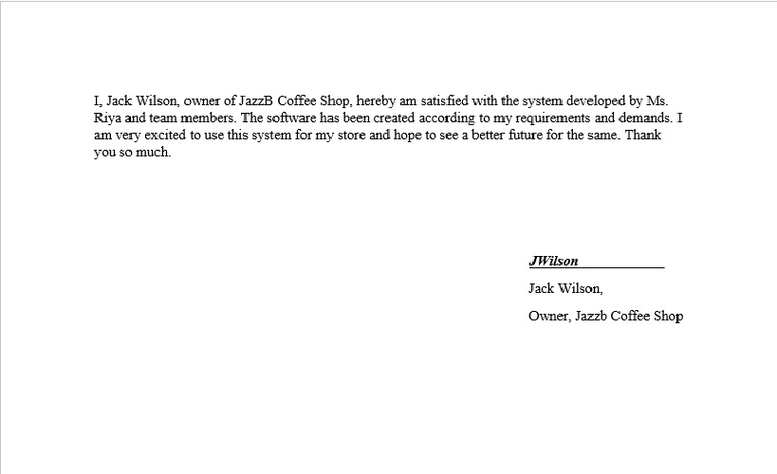

Software verification, testing, and validation for quality assurance

After every User story was completed, acceptance testing was performed in front of the client of that user story. The client watches the demonstration and gives back the feedback to the project team. The feedback is then studied upon and helps the project team to rectify any mistakes it has made to meet the requirements.

* Generated GUI design using Eclipse IDE and translated the same into pure Java code.
* SQL server code is the backend code generated.
* Unit testing performed on each newly created functions
* The front end and the back end that is Java and SQL server were integrated and system testing was performed.
* Eventually the entire cycle was reviewed.
* As mentioned in the Part 1 documentation, we have followed the Agile Methodology aligned with Extreme Programming (XP). XP is a taught way to deal with conveying brilliant programming rapidly and ceaselessly. The four standards of XP are: Simplicity, Communication, Feedback and Storage.

- Extreme programming (XP) is a product advancement system which is expected to enhance programming quality and responsiveness to changing client prerequisites. As a kind of nimble programming advancement, it advocates successive "discharges" in short advancement cycles, which is proposed to enhance efficiency and present checkpoints at which new client necessities can be embraced.

**[_____/20 marks, SLO-1, SLO-2, SLO-3, BLO-K1, BLO-S3] Demonstrate the Project development and release ICT infrastructure.** This must include development environment, programming languages, source code repositories (Configuration Management), project collaboration tools, and development tools. Write here: minimum **TWO** pages, maximum **TEN** pages.

* [____/10 marks] **Configuration Management**/version control, e.g. git, github, heroku, bitbucket; Project tools. Programming languages/IDEs. Building tools/procedures. How to set-up your development/release environment for a new team member.
* The entire project is stored in GitHub. It will be shared with our entire team. The updated codes and other developments will be shared to the entire group without any hassle. We have used GitHub because it is very user-friendly and convenient.
* Programming languages used are Java (for front end) and MySQL(for back end).

Java: Programming language used for creating front-end components.

MySQL: Utilized for information stockpiling and administration. (MySQL Workbench.)

* Development tools used are: Eclipse IDE, NetBeans IDE, MySQL Workbench

Eclipse IDE: contains base workspace and an extensible plug-in system for customizing the environment, primarily used for Java Programming.

NetBeans IDE: An open sourced IDE, used to develop applications.

MySQL Workbench: It is a design tool used to collaborating SQL development, administration, implementation, maintenance and creation onto a single development platform for development of the MySQL database system.

* Customer Testing Protocols:

Main Menu

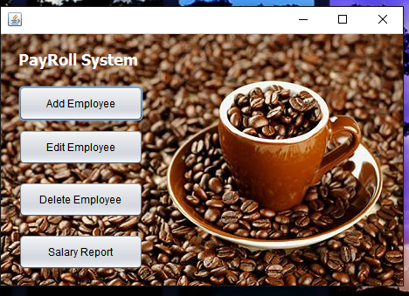

Adding a New Employee:

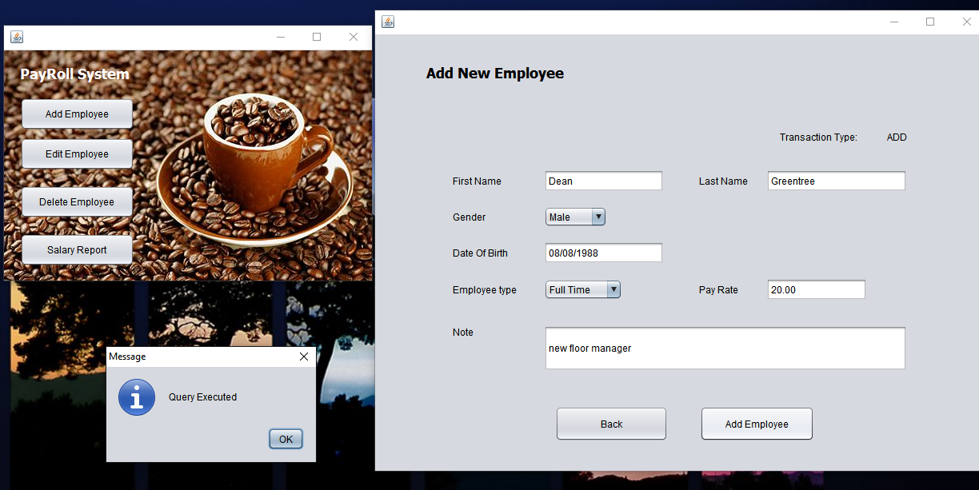

Edit an Existing Employee:

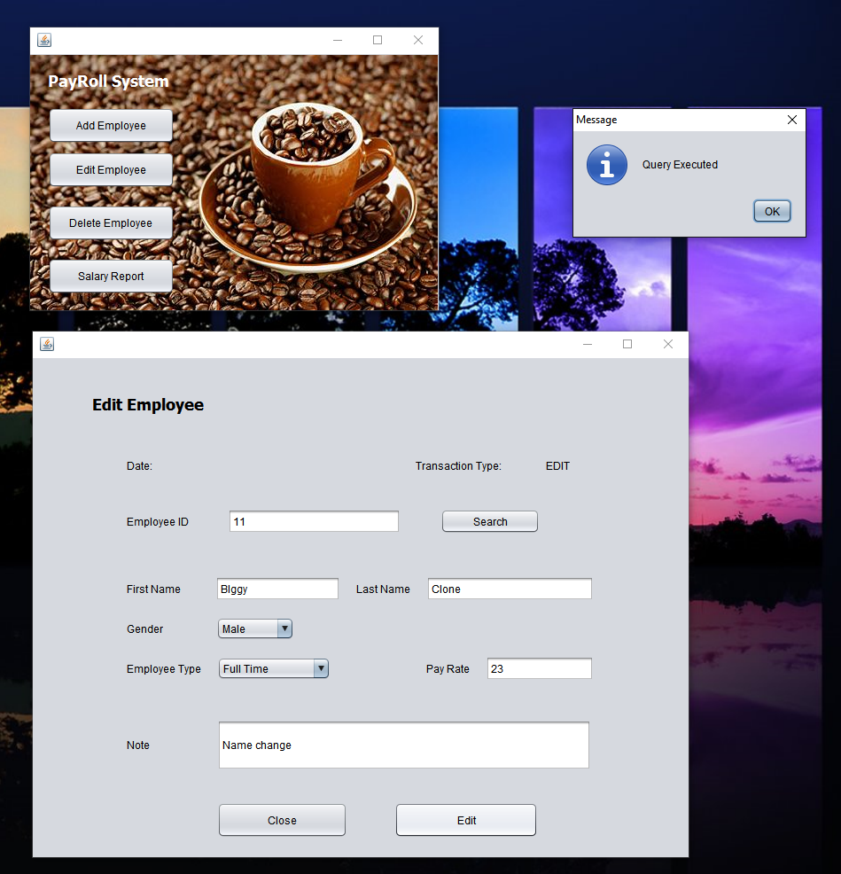

Delete an Existing Employee:

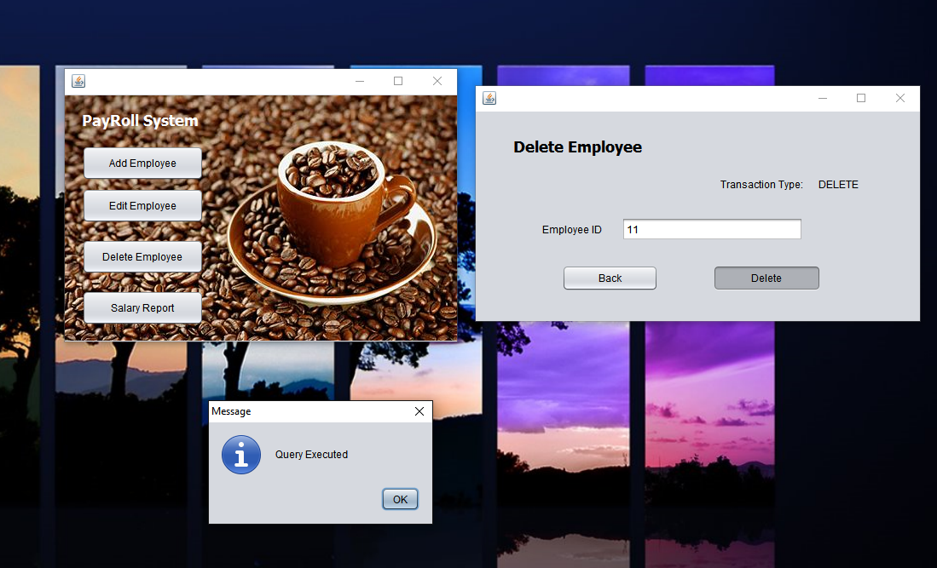

Add Time Card:

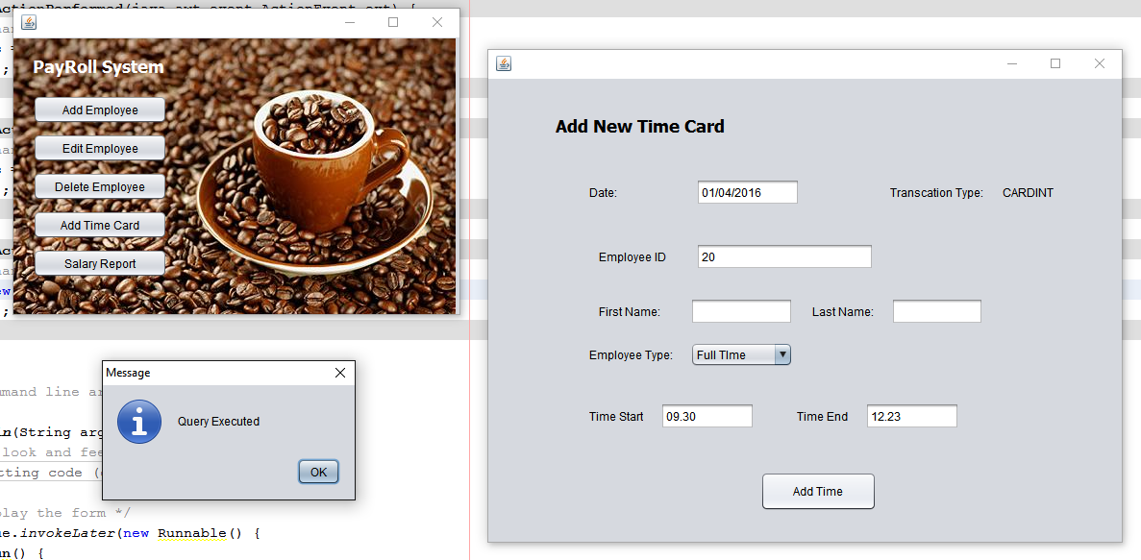

SQL TABLES:

Add Employee Table:

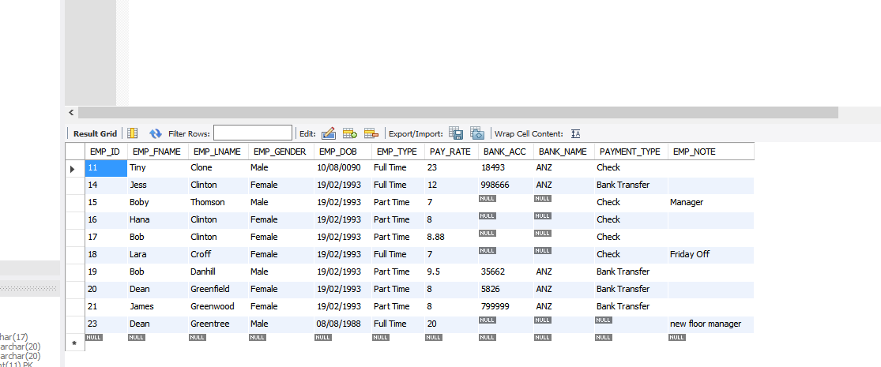

Edit Employee Table: (changed data table)

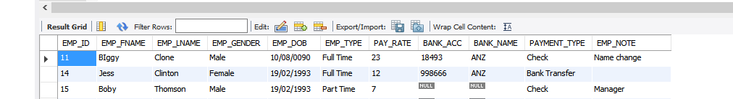

(search data table)



(search function table)

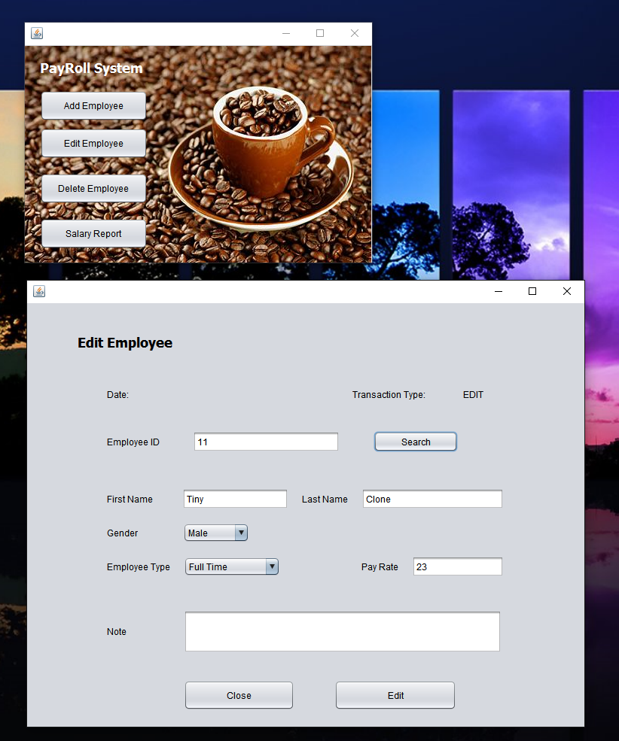

Employee data table:

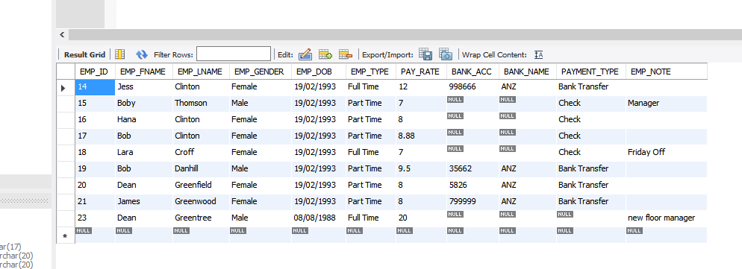

Time card data table:

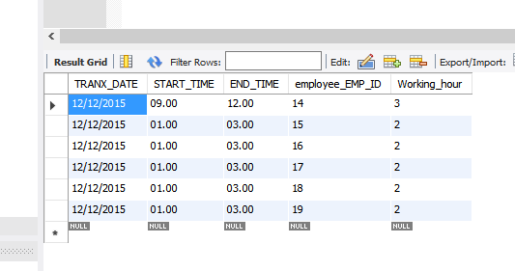

Salary report data table:

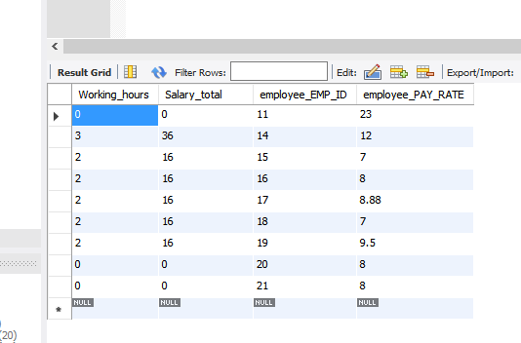

Salary report form execute:

